**Mighty marker High Purity**



®

**Nuclear Grade • Low Chloride • Low Corrosives • Laboratory Certified**

# Thorough testing and formulation that fulfills the the needs of various specialty applications.

**®**



**VALVE CONTROLLED**

These marking pens contain high-purity inks for safely marking nuclear pipes, vessels, stainless steel, and titanium. Welding operations, automotive plants, and aircraft industries can also benefit from them. The ink/paint has been certified by an outside laboratory and will not contaminate or adversely effect the surfaces being marked.

Inks and paints meet or exceed the requirements of:

* GE# D50TF8-S7 “Nuclear Grade”
* Nuclear Plant # TEC 10000028213
* Pratt & Whitney # PWA 36700
* Rolls Royce # EMA 56752
* Chicago Bridge & Iron
* Westinghouse APP-GW-Z0-602
* Various other aerospace and nuclear grade specifications



# Included in your purchase:

These markers include certification paper-work, lab-report paper-work, local-law compliant labeling for shipment and storage, SDS sheets corresponding to the particular batch, and letters of compliance with the specs requested.

## MM-06



WARNING:

Cancer and Reproductive Harm - [www.P65Warnings.ca.gov.](http://www.P65Warnings.ca.gov/)



### Stroke

1.0mm Extra Fine Tip

### Paint/Ink Content

3ml

### Temperature Range

*For black, use at:*

-20ºF to 130ºF

(-29ºC to 130ºC)

*For all other colors, use at:*

-40ºF to 150ºF (-40ºC to 66ºC)

### Solvent System

*For Black:*

Dye Based “Alcohol“

*All other colors:* Pigmented Paints “Aromatic Solvent”

**Replacement Nibs** (Polyester or Acrylic) #00085

Extra-Fine Bullet Nib

### Barrel

Aluminum

### Packed

12 per box

144 per carton

576 per master carton

## MM-07



### Stroke

1.2mm Fine Tip

### Paint/Ink Content

4ml

### Temperature Range

*For black, use at:*

-20ºF to 130ºF

(-29ºC to 130ºC)

*For all other colors, use at:*

-40ºF to 150ºF (-40ºC to 66ºC)

### Solvent System

*For Black:*

Dye Based “Alcohol“

*All other colors:* Pigmented Paints “Aromatic Solvent”

**Replacement Nibs** (Nylon or Polyester) #00070

Fine Bullet Nib

### Barrel

Aluminum

### Packed

12 per box

144 per carton

576 per master carton

## MM-08



### Stroke

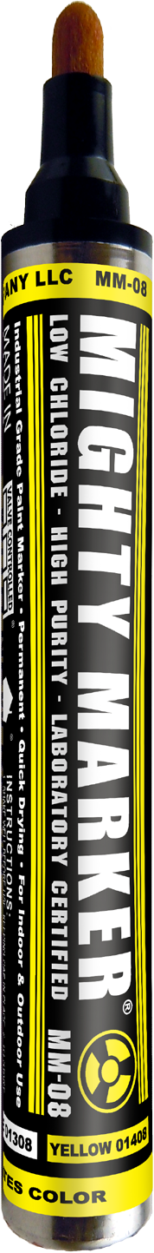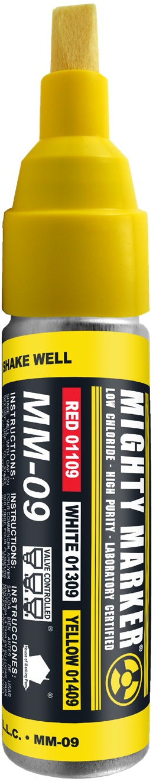3.2mm Bullet Tip 4.8mm Chisel Edge

### Paint/Ink Content

13ml

### Temperature Range

*For black, use at:*

-20ºF to 130ºF

(-29ºC to 130ºC)

*For all other colors, use at:*

-40ºF to 150ºF (-40ºC to 66ºC)

### Solvent System

*For Black:*

Dye Based “Alcohol“

*All other colors:* Pigmented Paints “Aromatic Solvent”

**Replacement Nibs** (Acrylic or M-felt) #00080

Dual Bullet/Slanted Chisel Nib

### Barrel

Aluminum

### Packed

12 per box

144 per carton

576 per master carton

## MM-09



### Stroke

1.2mm Chisel Fine Edge 4.2mm Chisel Medium Edge 7.2mm Chisel Broad Edge 3.2mm Bullet Tip***

### Paint/Ink Content

17ml

### Temperature Range

*For black, use at:*

-20ºF to 130ºF

(-29ºC to 130ºC)

*For all other colors, use at:*

-40ºF to 150ºF (-40ºC to 66ºC)

### Solvent System

*For Black:*

Dye Based “Alcohol“

*All other colors:* Pigmented Paints “Aromatic Solvent”

### Replacement Nibs

#09000

Acrylic or M-Felt Chisel Nib #02200

M-felt Bullet Nib

***Bullet available for Black only.

### Barrel

Aluminum

### Valve Assembly

U.S. Patent #: 7,086,799

### Packed

6 per box

72 per carton

|  |  |  |  |  |
| --- | --- | --- | --- | --- |
|  | **Black Ink (XV-12149)** | **White Paint (XV-790)** | **Yellow Paint (XV-791)** | **Red Paint (XV-830)** |
| **MM-06** | 00106 | 01306 | 01406 | 01106 |
| **MM-07** | 00107 | 01307 | 01407 | 01107 |
| **MM-08** | 00108 | 01308 | 01408 | 01108 |
| **MM-09** | 00109 | 01309 | 01409 | 01109 |

**More colors available by special request.**

**Mighty Marker® High Purity paints and inks are also available in 4oz, 6oz, and 1gal containers**

**American Marking Inc.**

2435 Vale Drive, Birmingham AL 35244

**Toll Free**: 1-800-964-6275

**Phone:** (205) 987-0151 | **Fax:** (205) 733-1720

**Website:** [www.americanmarking.com](http://www.americanmarking.com)| **Email: americanmarking@aol.com**